**Calculation For EMDB**

**EMDB load= Total ESDB Load * 0.7 + Emergency Lift Load * 0.7**

Total ESDB Load=9*4*ESDB_Each Unit+ ESDB_Ground + ESDB_Basement + ESDB_Lobby

**EMDB Current= $\frac{EMDB Load}{\sqrt{3}*Line Voltage*pf}$**

Phase Voltage = 220 V

Line Voltage = $\sqrt{3}$* 220 = 381.05 V

Power Factor, pf = 0.8

Total ESDB Load = 9*4*280+238+196+9*42 = 10892 W = **10.892 kW**

Emergency Lift Load = 7 kW

**EMDB Load= 0.7* (10.892+7) = 12.5244 kW**

**EMDB Current= $\frac{12.5244*1000}{\sqrt{3}*381.05*0.5}$ = 23.72 A**

**So, 30 A TP MCCB is needed from EMDB to MDB.**

**Wire is 4x10 rm NYY + 10 rm BYA ECC (Ref: PWD RATE SCHEDULE for Subhead Wiring and Cables 1.14.1.4)**

**Generator Sizing**

EMDB LOAD =12.5244 KW, Assumed pf = 0.8

Generator size= EMDB LOAD/pf = 12.5244 kW/ 0.8

**= 15.66 KVA**

**FROM PWD RATE SCHEDULE (Subhead-2.2 Generator & Related works):**

**20 KVA with ATS is available (Item No. 2.2.1.2.2)**

**Calculation for MDB**

MDB Load = Total SDB Load * 0.7 + (EMDB Load + Pump Load) * 0.7 + 0.7* Main Lift Load

Total SDB Load = 9*4*SDB_Each Unit + 9* SDB_Lobby + SDB_Ground + SDB_Basement + SDB_Roof

= (9*4*8297 + 9*28 + 4893 + 238+70) W

**= 304145 W = 304.145 KW**

Pump Load = 10000 W

Main Lift Load = 7 kW = 7000 W

**MDB Load = 304145 * 0.7 + (12524.4 +10000) * 0.7 +0.7* 7000 = 233567.58 W = 233.57 kW**

**MDB Current= $\frac{MDB Load}{\sqrt{3}*Line Voltage*pf}$ = $\frac{233567.58}{\sqrt{3}*381.05*0.8}$ = 442.37 A**

So**, 500 A TP MCCB** is needed from **MDB to Main Line**.

Wire: 4x 400 rm NYY +185 rm BYA ECC (PWD RATE SCHEDULE for Subhead Wiring and Cables 1.14.1.16)

**Pump Current Calculation**

Pump power = 10000 W 3 phase; assumed pf= 0.8

Pump Current= $\frac{10000}{\sqrt{3}*381.05*0.8}$ **= 18.94 A**

**CB: 20 A TP MCCB**

Wire: 4x 6 rm NYY +6 rm BYA ECC (PWD RATE SCHEDULE for Subhead Wiring and Cables 1.14.1.3)

**Calculation for Transformer**

Apparent Power, S= $\sqrt{3}$* V * I = 3* 220 * 432.992 **= 285774.72 VA = 285.775 kVA**

**Taking an overload factor of 0.9**

required Transformer = 285.775 KVA/ 0.9 = 317.53 KVA

So, 11/0.415 kV, 50 Hz, 315 kVA, DYN 11, Oil Immersed Transformer with 4-6% Impedance is needed.

(reference) PWD RATE SCHEDULE 2.1.4.6

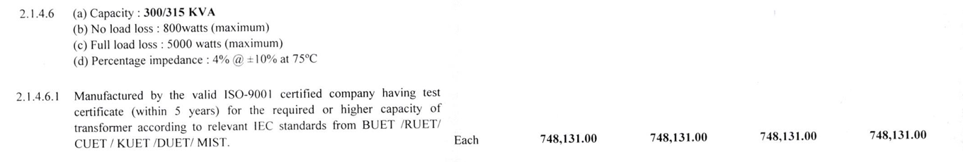

**Lift Sizing**

**Main/Emergency Lift Load =7 KW**, Assumed pf = 0.8

Line Current for = $\frac{7000}{\sqrt{3}*381.05*0.8}$ **= 13.26 A**

**CB: 15 A TP MCCB**

Wire: 4x 4 rm NYY +4 rm BYA ECC (PWD RATE SCHEDULE for Subhead Wiring and Cables 1.14.1.2)

**Calculation for PFI Plant:**

Desired power factor=0.95; Ѳ2=18.1950

**Qreq**=P (tanѲ1 – tanѲ2) = 228619.58 * (tan (36.86) - tan (18.195)) = 96259.363 VAR =**96.26 kVAR**

Current supplied by PFI,

I= $\frac{96.26*1000}{3*220*1}$ = **145.85 A**

CB: 150 TP MCCB

Wire: 4 x 120 rm NYY + 70 rm BYA ECC (PWD RATE SCHEDULE for Subhead Wiring and Cables 1.14.1.11)

Link For PWD: [Public Works Department](https://ss.pwd.gov.bd/sor/sordownload/2)